Disabling or Tuning Feed Reports Locally

Disabling/Tuning
**NOTE** You must be global admin in order to view the Threat Intelligence Pages.
- Navigate to the Threat Intelligence Page:
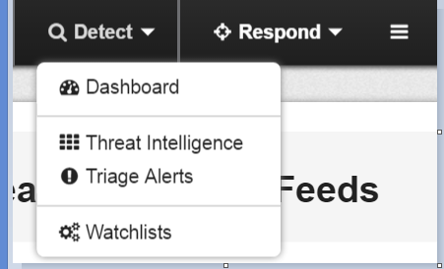

- Click on the threat reports for the feed you want to tune:
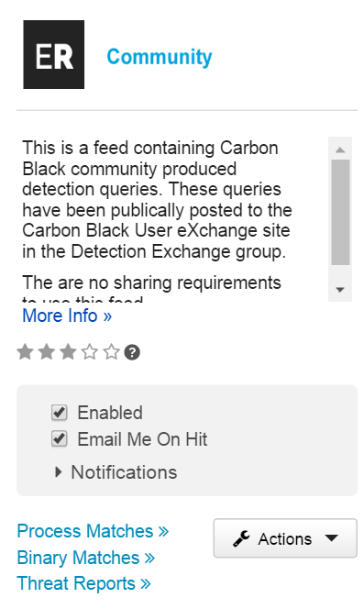

- If you just want to disable a query, flip the “Ignore” button from “No” to “Yes”. Once you do this, the report will no longer run and tag any data on your server.
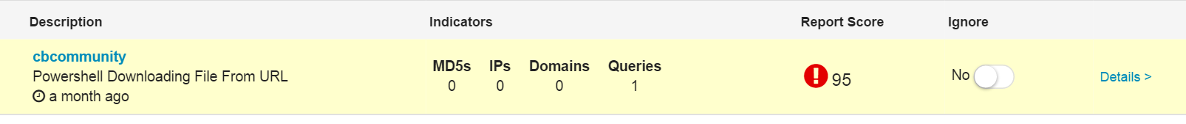

- If you want to customize a query to your environment, disable the feed query, then click on details to go into a specific details page, then click on the blue hyperlinked “indicator” at the bottom:
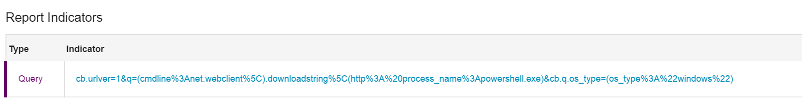

- This opens up a process search page with the query that the threat feed is running:
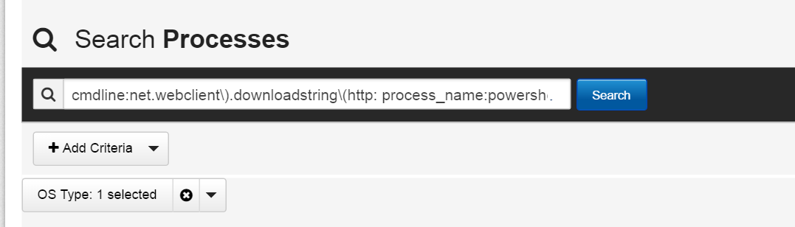

- Once you’re here, add or remove search terms to your query until you’ve found something that eliminates the noise in your environment but will still catch malicious/unusual behavior. Then “add watchlist”:
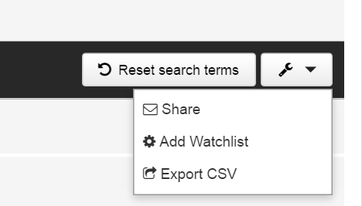

- Set the alerting the way you want it, and save changes:
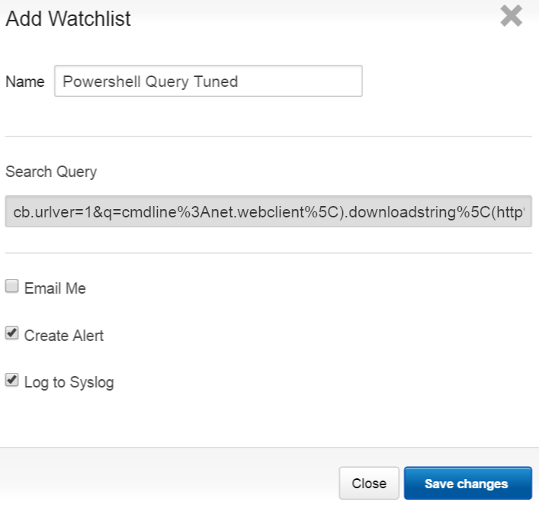
- Please let us know on the User eXchange how you tuned your watchlist so we can track common tuning patterns and improve the base queries.

Tracking query updates
If you have disabled a feed query and created a custom watchlist for your environment, you may still want to be aware of query updates (for instance, if malicious behavior evolves and we add parameters to catch a new variant.)
Changes to queries in the feeds are announced on the User eXchange, in the Threat Intel Group. New queries and updates to queries are always announced under the title “Forthcoming Queries”. These posts will also be tagged with the tag “feed_updates”. Please configure your User eXchange settings accordingly to receive email notifications when these titles or tag are used.

